Exercise List

# Rian Koja

# CAP 239 Computational Mathematics

## Exercise 1

### GRNG

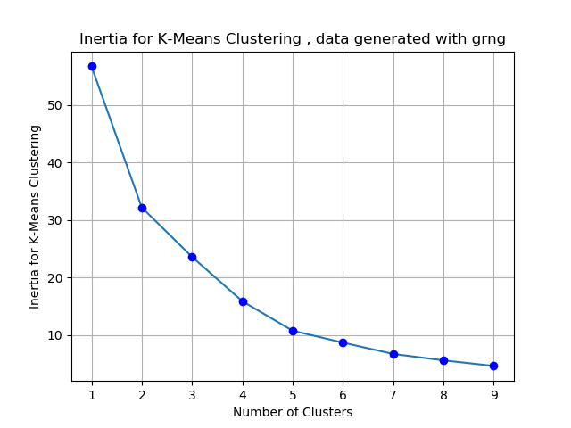

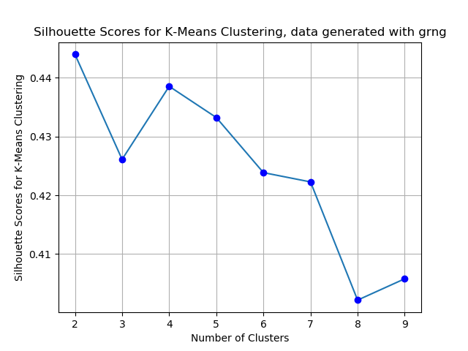

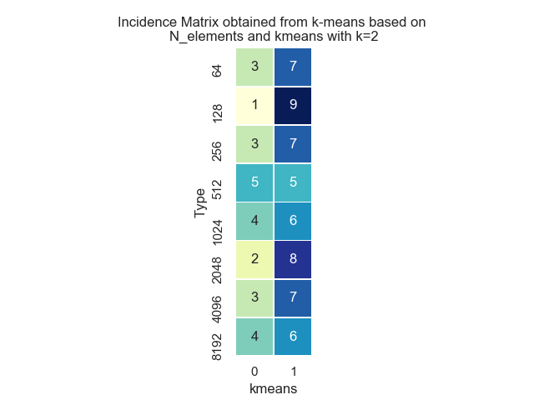

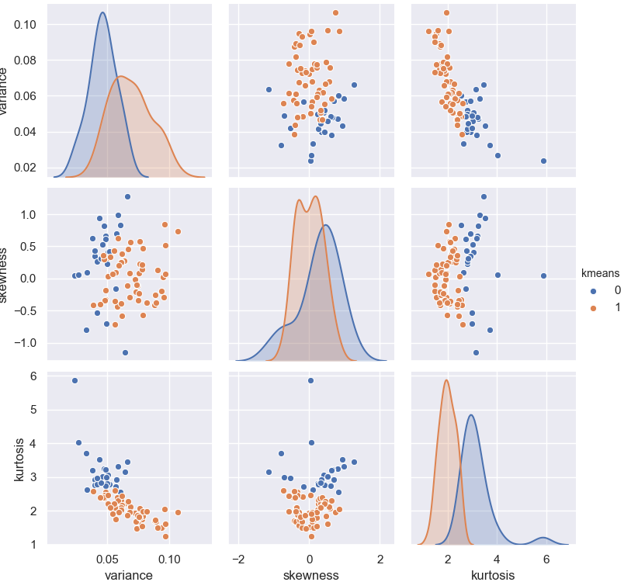

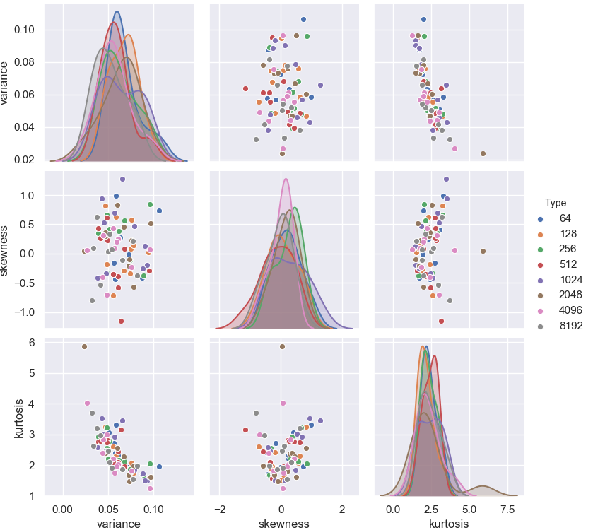

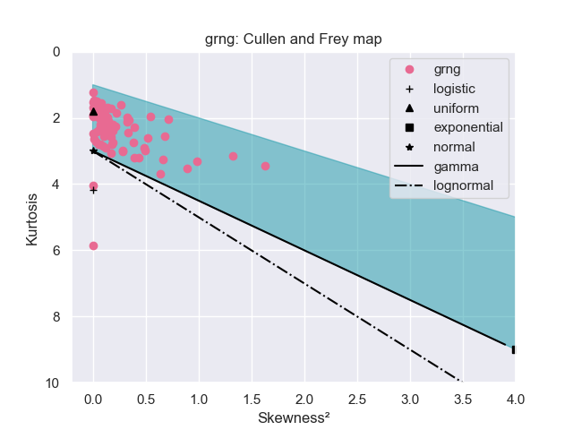

## Exercise 2

### Colored Noise

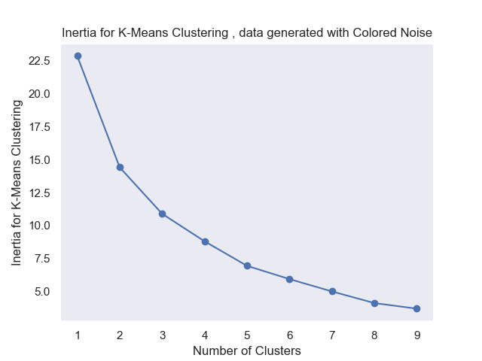

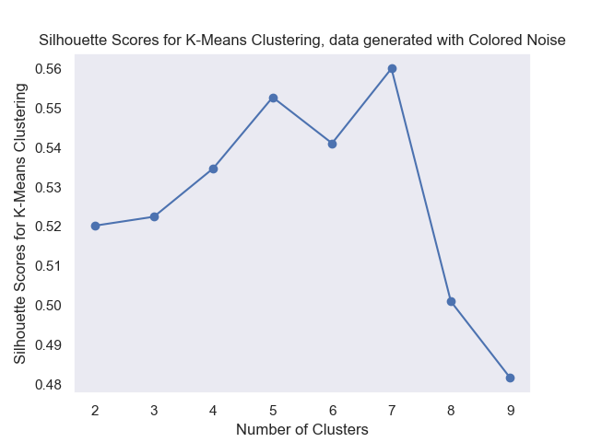

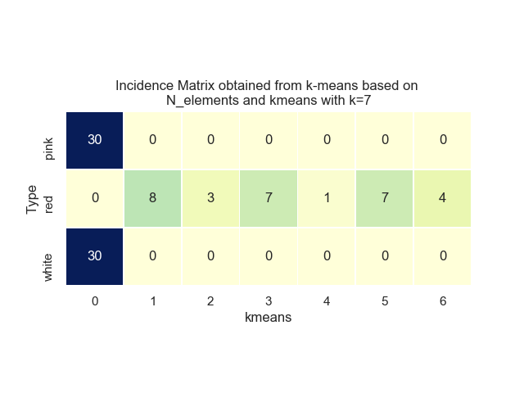

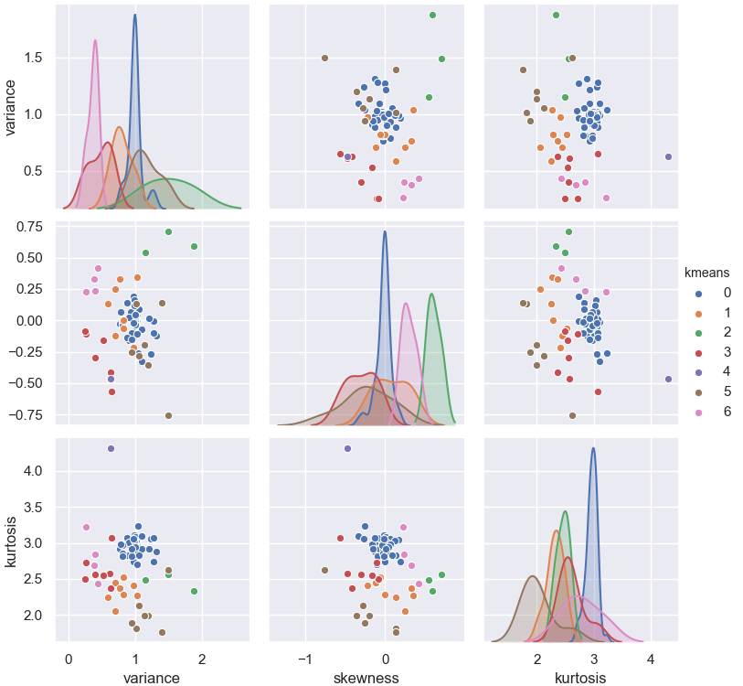

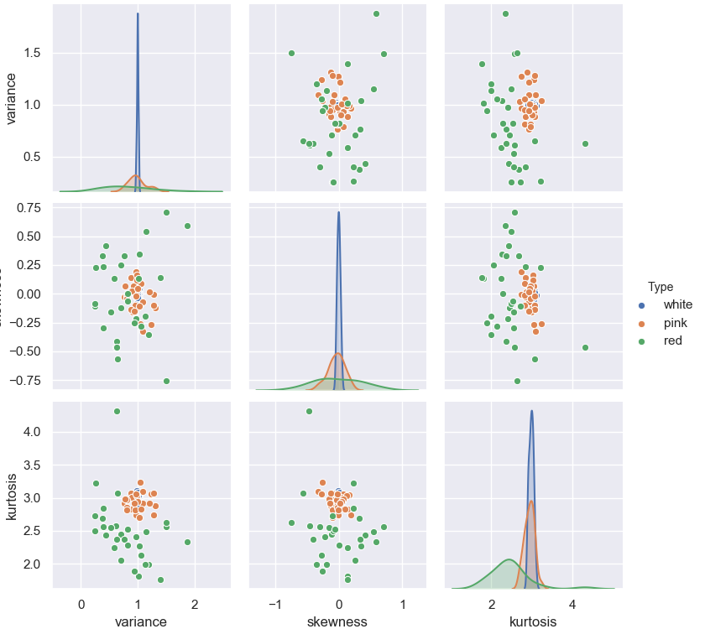

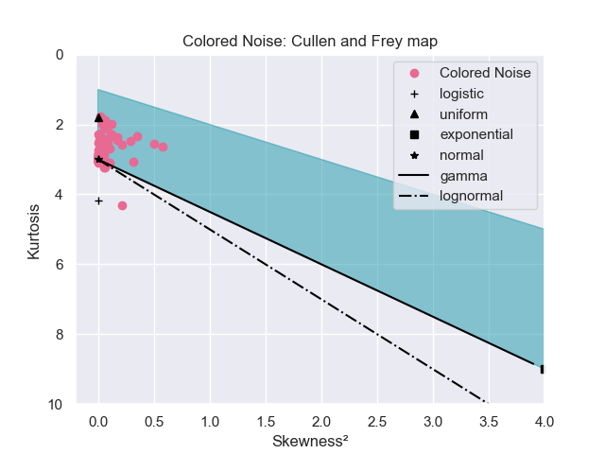

## Exercise 3

### P-Model

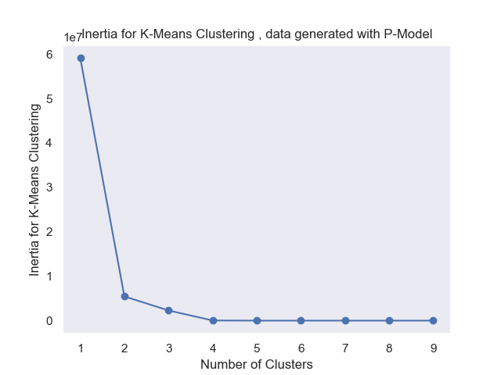

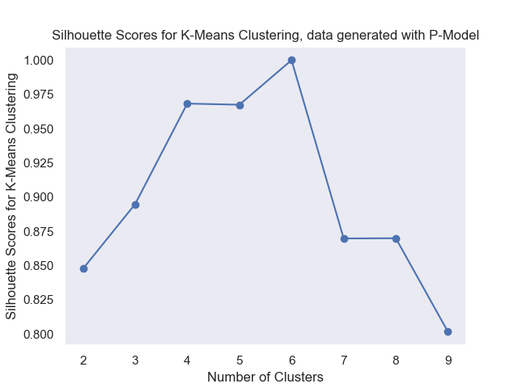

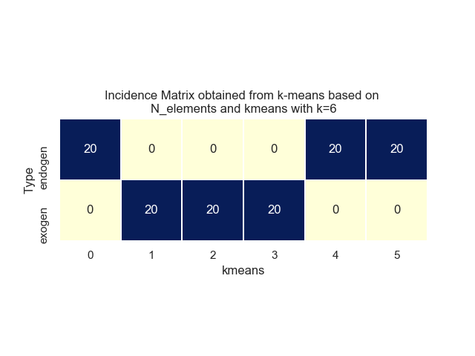

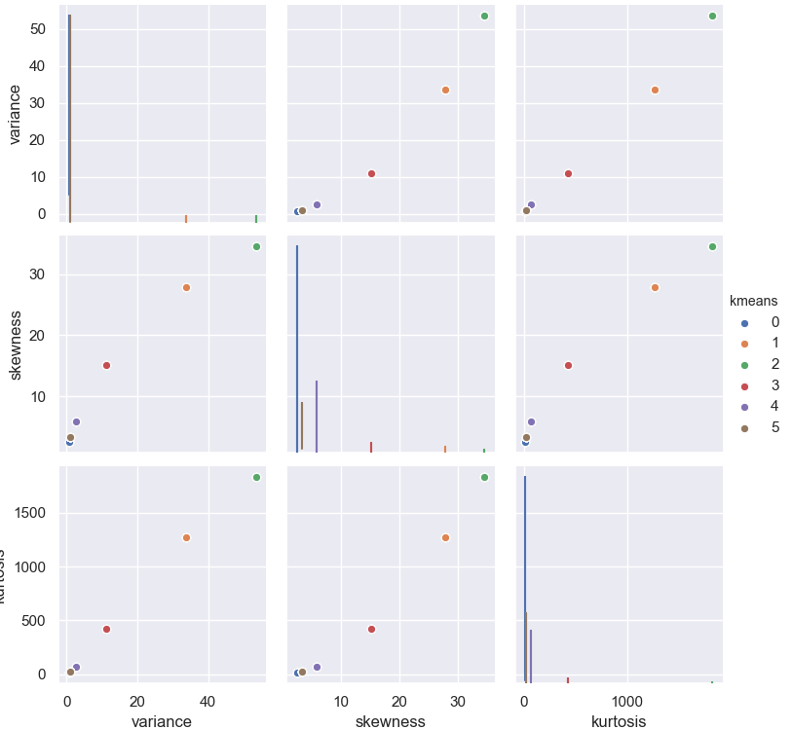

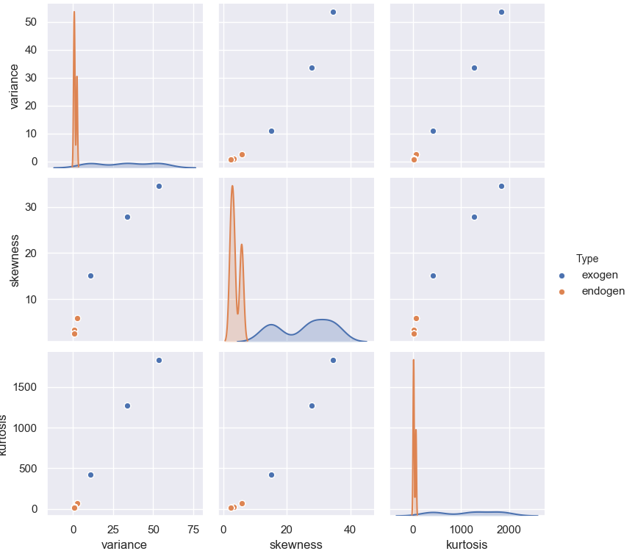

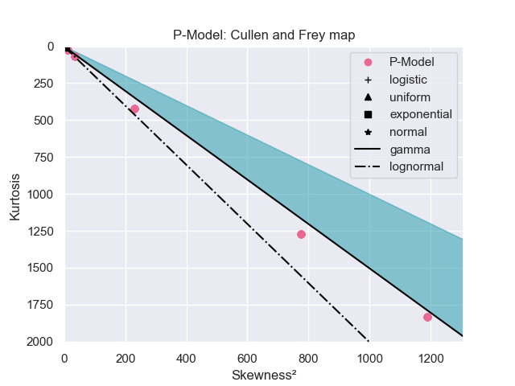

## Exercise 4

### Exercise 4.1

This exercise produces results for each of the generators used in the prior exercises, thus such results were shown in the previous sections.

### Exercise 4.2

Here we compare different methods of estimating a probability density function from sampled data.  
The first is to use Kernel Density Estimation, a standard method to compose a PDF as a pondered sum of PDF's centered at each observed point.  
The second is a parametric estimation, done for both Gaussian distribution and Generalized Extreme Value distribution. With this technique, a best parametric fit for the observed data is found, and the curve is plotted based on the parameters found.  
For each kind of noise, the type is indicated in the plot title, along with the values estimated for parameters.

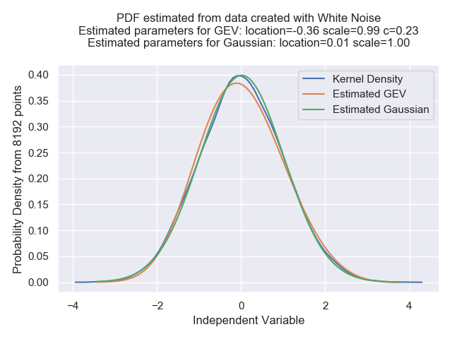

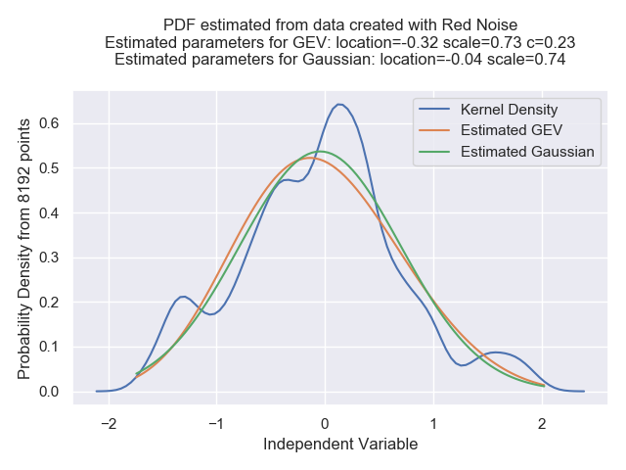

## Exercise 5

For Henon map:

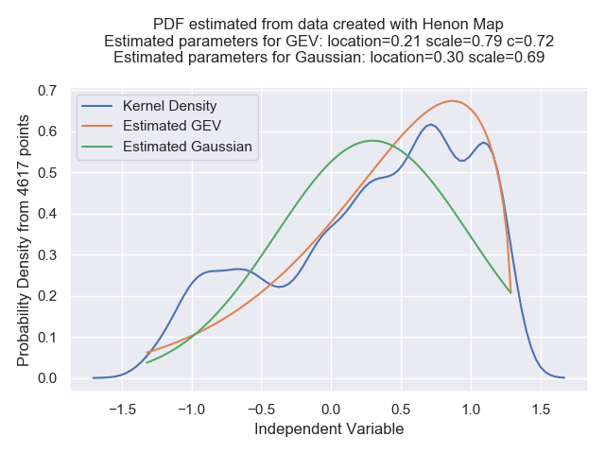

For Logistic map:

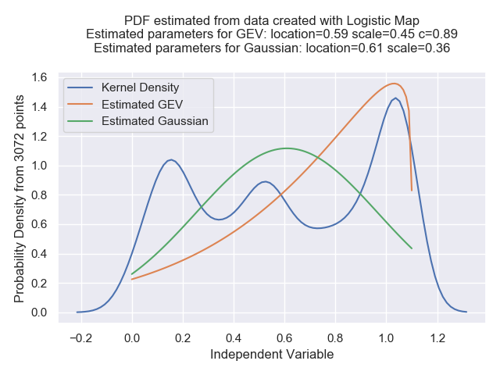

## Exercise 6.1

The P-Model will be excluded, since it provides data series with high kurtosis and skewnessthat would prevent effective clustering with K-Means

### For Non Gaussian Random Generator:

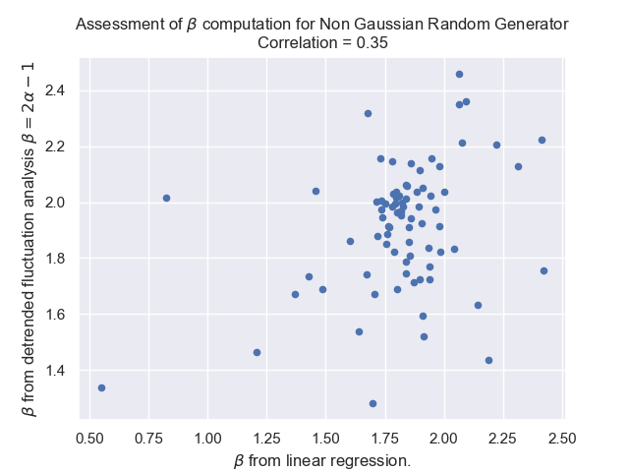

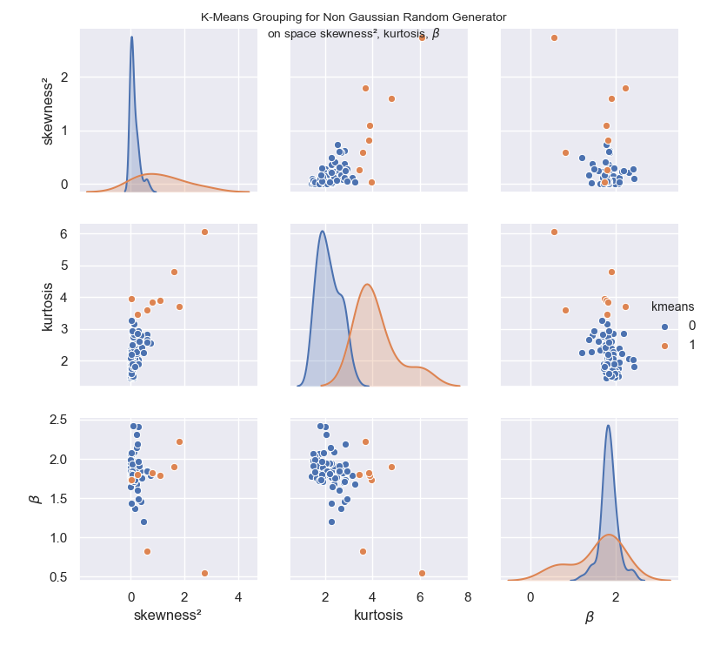

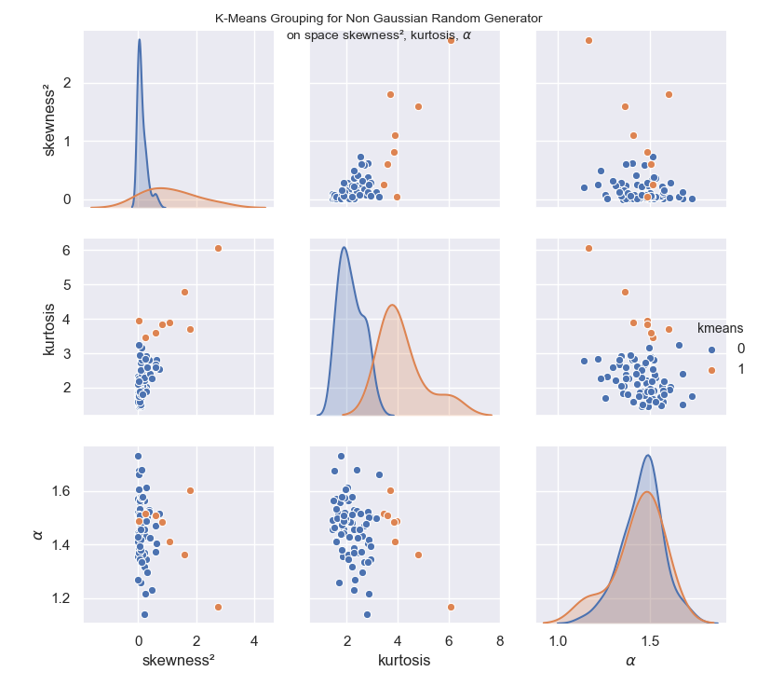

### For Colored Noise Generator:

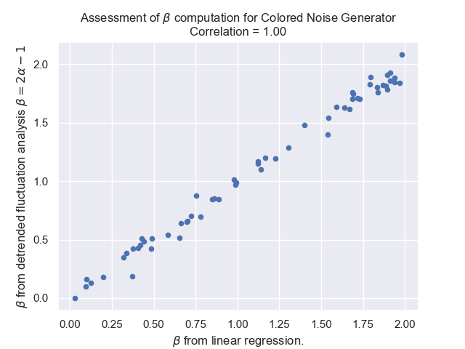

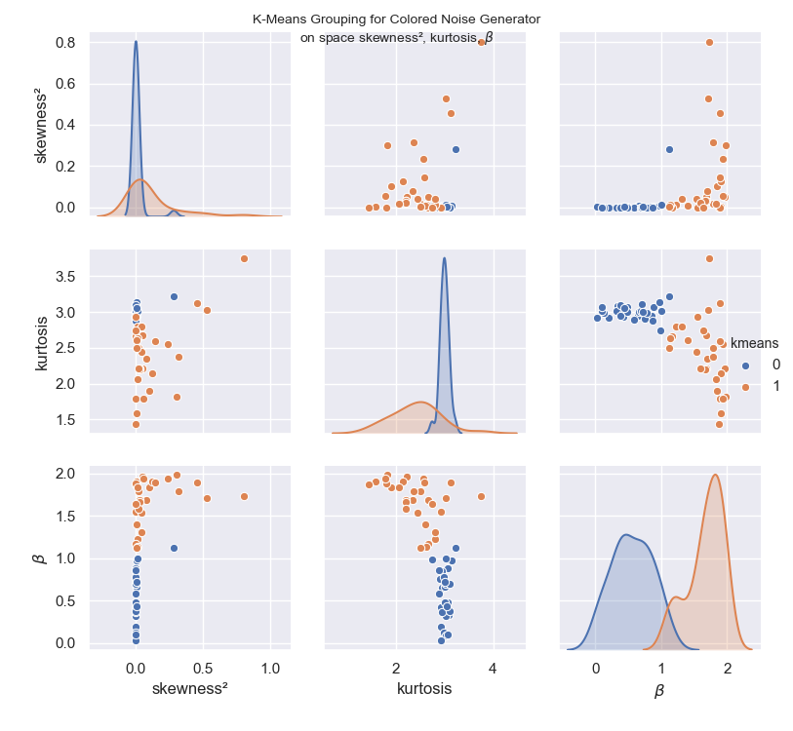

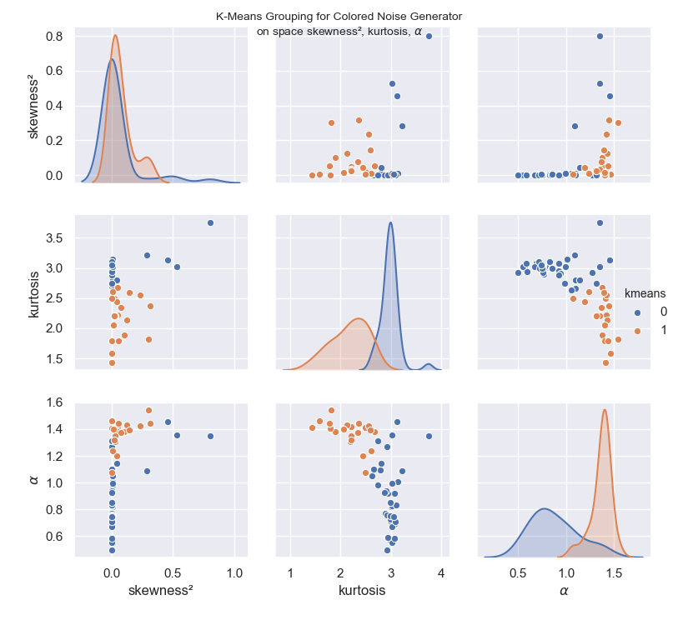

### For Logistic Map:

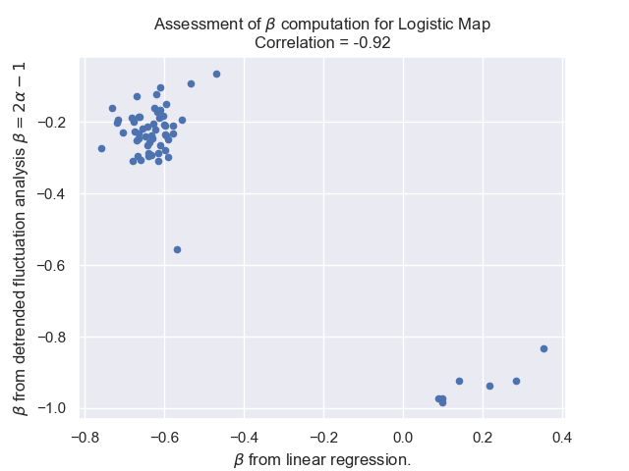

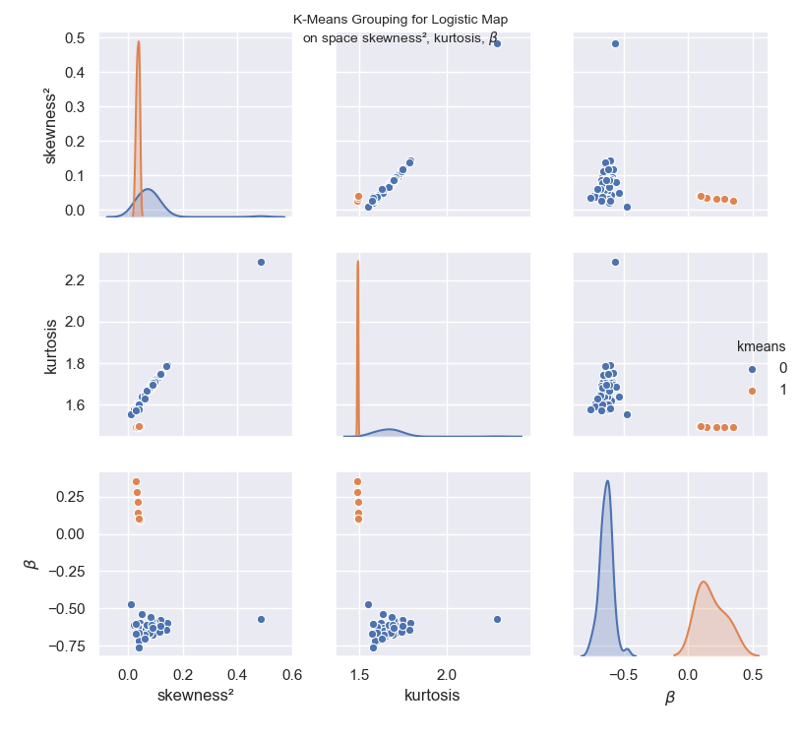

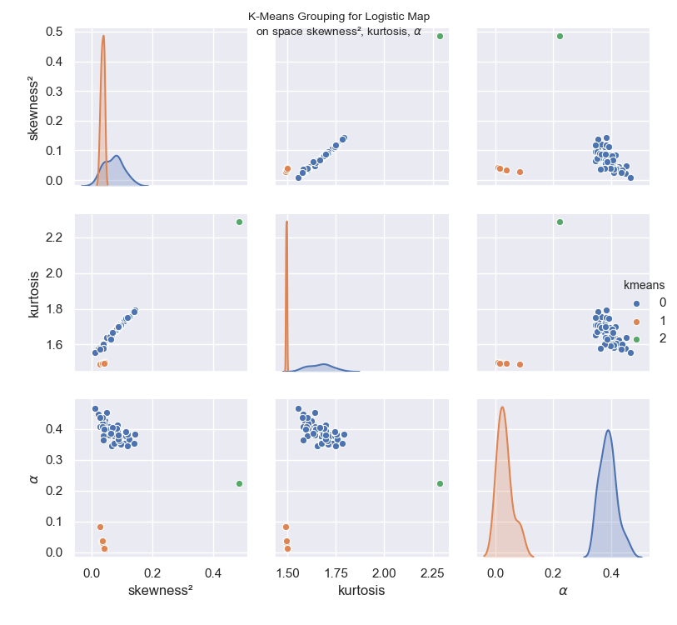

### For Henon Map:

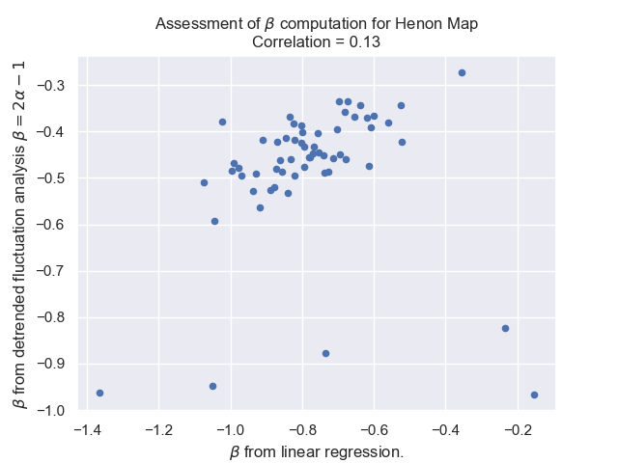

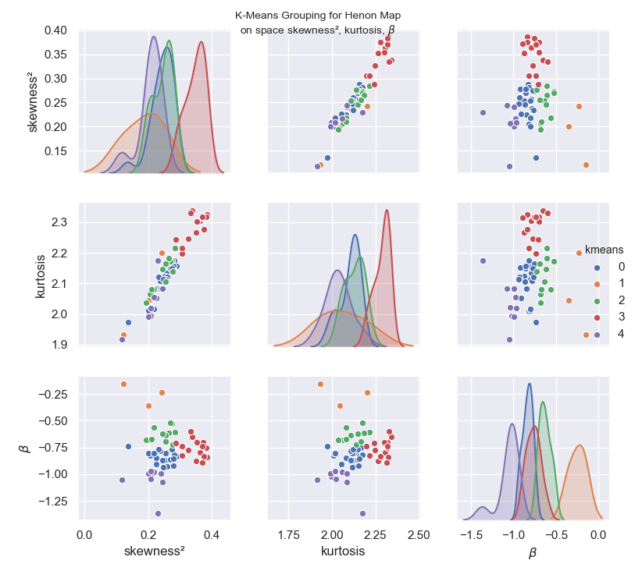

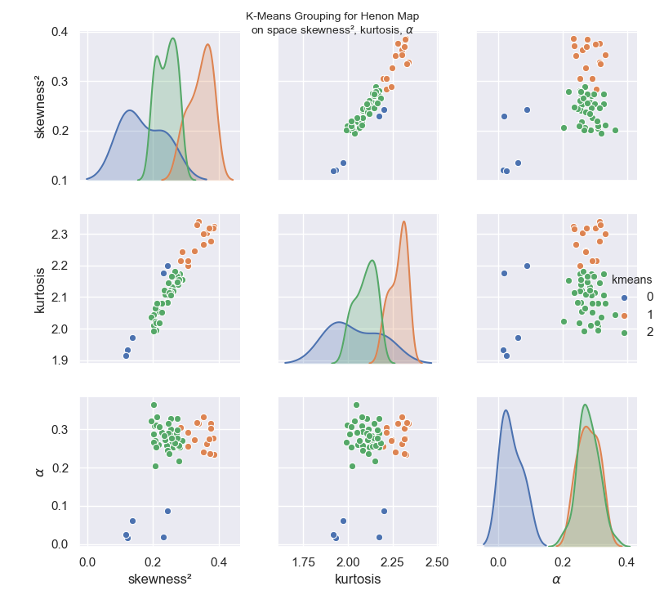

### Combining all data series:

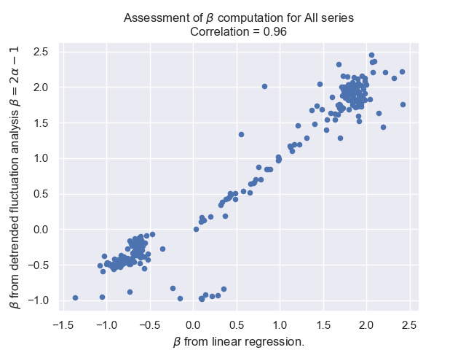

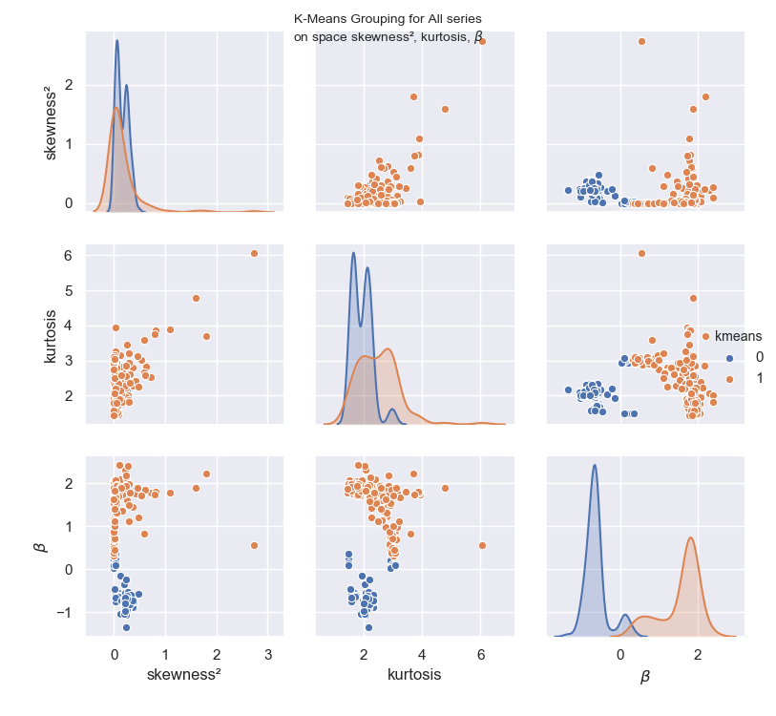

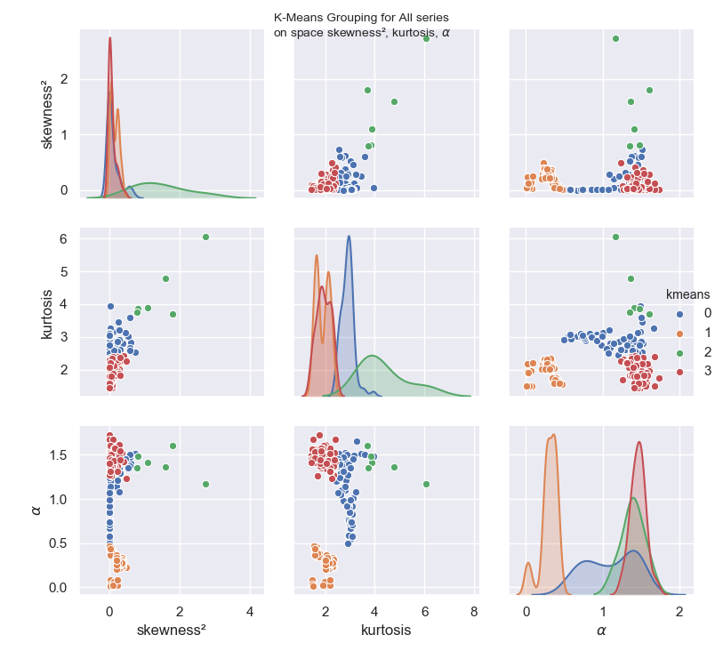

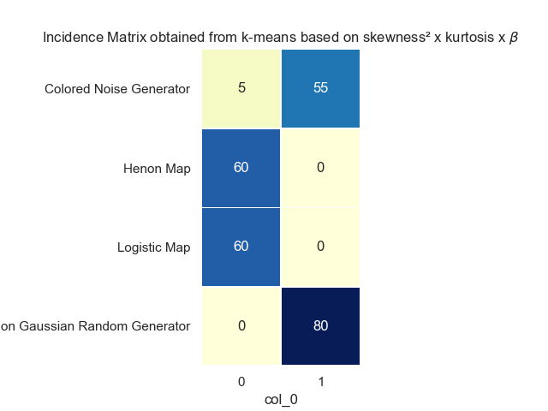

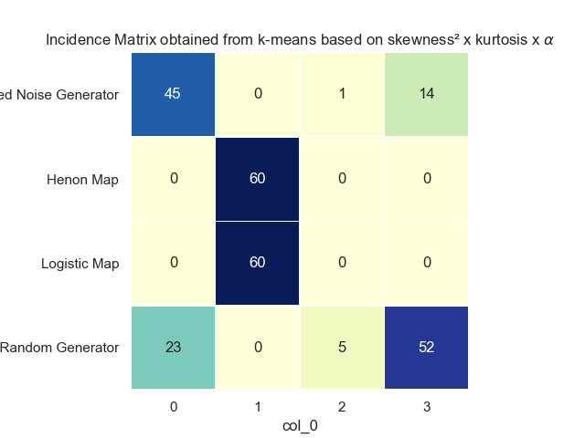

## Exercise 6.2

Using provided data sets and new cases of COVID-19 in the USA.

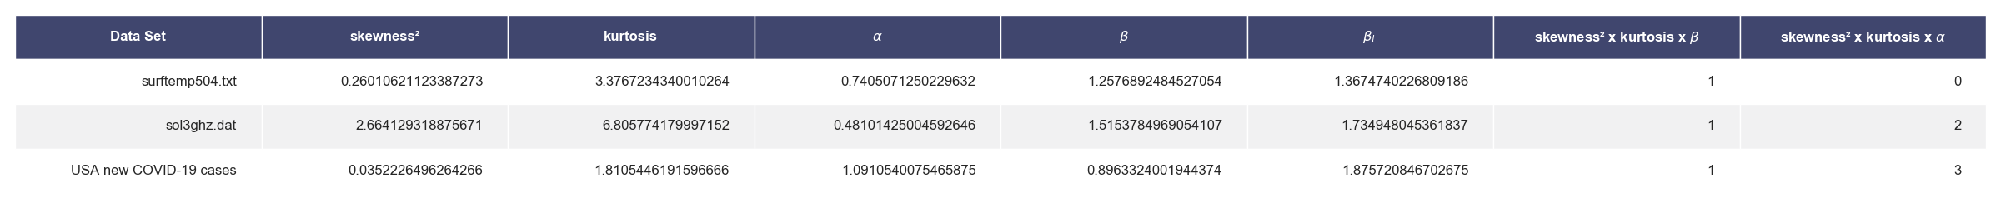

All datasets would get classified on the same group, if P-Model was included on the training data, since the grouping would basically be dominated by the high kurtosis and skewness of p-model series.  
It can be seen that the behavior of the US series was clustered along with the colored and non-gaussian noises, which makes sense assuming that the number of new daily cases should be directly proportional to the number active cases, more specifically the number of people in the contagious stage of the disease, which in turn is dependent on the number of new cases of a few preceding days. While this makes sense for more closed regions, the US seems to have a dynamics of the disease spreading at exponential rate initially once it reaches a new state or city, thus the closer similarity to the Non-Gaussian noise behavior instead of the colored noise.

Meanwhile, the data series in surftemp504.txt and sol3ghz.dat, are clustered with the random noise in the space with beta, but particularly the sol3ghz.dat gets isolated in its own group when clustering with alpha. Given the correlation between alpha and beta, this might just be an effect of the lack of normalization or scaling prior to applying the K-Means technique. It might also be an effect of the data being

## Exercise 6.3

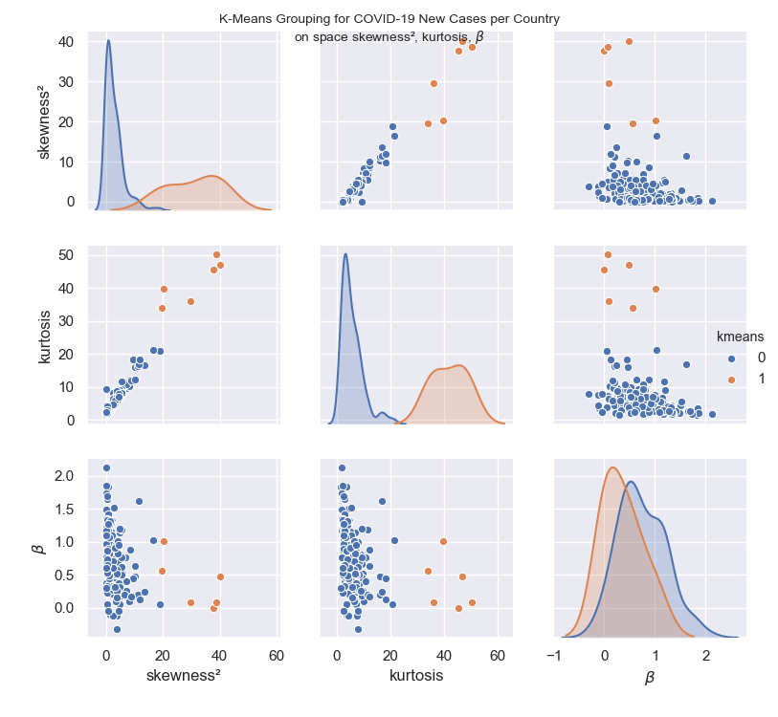

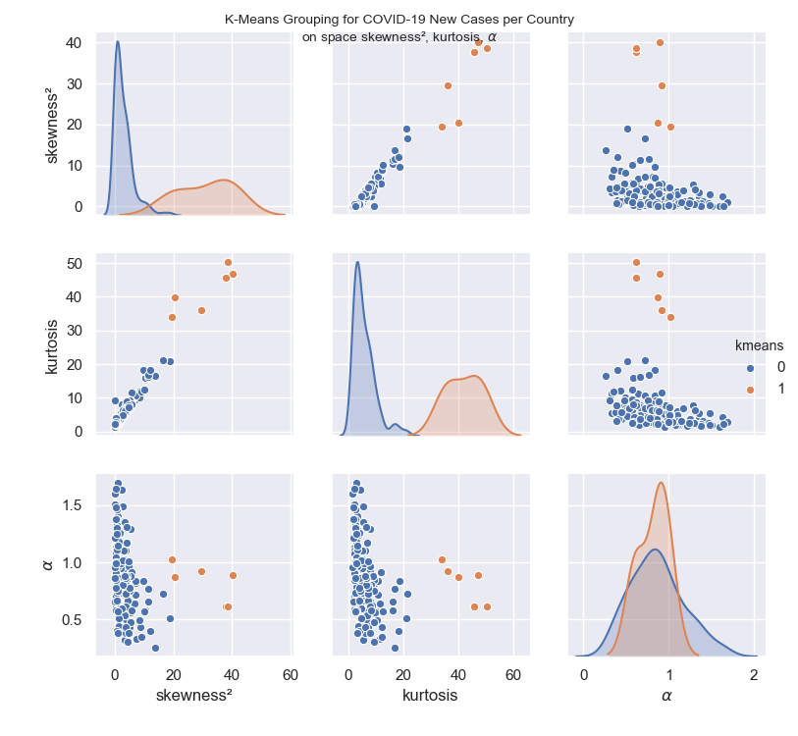

Below is the data set created for most countries available in the data collected from "Out world in Data" website. Only countries with a minimum data diversity were selected, bychecking if the number of new cases had assumed at least 12 distinct values. This eliminates time series that are simply too short or that do not contain enough data richness to apply the available tools. Also, countries with negative alpha were removed. The maximum silhouette coefficient method was employed to select the number of clusters, which ended up being 2. The main group has hte majority of countries, whereas high kurtose, high skeness and high alpha or beta, which apparently correlates with countries in early stages of the epidemic, where daily new cases are growing steadily rather than slowing down or retreating.

skewness² kurtosis $\alpha$ $\beta$ $\beta_t$ name kmeans beta group  
0 4.929983 7.221562 0.435982 0.061070 -0.128036 Central African Republic 0 0  
1 40.198014 46.914262 0.892676 0.480947 0.785353 Faeroe Islands 1 1  
2 10.334728 16.079743 0.578482 0.473743 0.156965 Maldives 0 0  
3 1.450362 3.282174 1.117322 1.236345 1.234644 Brazil 0 0  
4 2.492821 4.352133 1.637202 1.506640 2.274404 Chile 0 0  
5 0.057677 2.293313 0.706568 0.731203 0.413136 Moldova 0 0  
6 0.202633 2.272529 1.135226 1.249922 1.270453 Singapore 0 0  
7 18.925393 20.857109 0.512753 0.057011 0.025505 Sao Tome and Principe 0 0  
8 3.879811 7.045874 0.853518 0.845341 0.707035 Myanmar 0 0  
9 1.702694 4.420856 0.792823 0.540704 0.585647 Greece 0 0  
10 7.307871 11.244210 0.334284 0.172003 -0.331431 Madagascar 0 0  
11 2.128978 4.532870 1.068096 1.316158 1.136192 South Africa 0 0  
12 0.333079 2.064823 0.986030 0.831893 0.972059 Slovenia 0 0  
13 0.057654 1.431185 1.602414 1.831753 2.204827 Russia 0 0  
14 0.101384 1.993995 1.506144 1.483928 2.012288 Italy 0 0  
15 8.648913 12.185164 0.432732 0.874363 -0.134537 Ethiopia 0 0  
16 4.121991 9.002183 0.850141 0.804730 0.700283 Malta 0 0  
17 0.039245 2.588524 0.960408 1.239643 0.920816 United Kingdom 0 0  
18 1.316442 3.155491 1.024742 0.846136 1.049484 Andorra 0 0  
19 4.721597 6.794799 0.485607 1.141171 -0.028787 Haiti 0 0  
20 0.981396 2.763731 1.693216 1.414986 2.386431 India 0 0  
21 2.175084 4.259268 0.834898 0.575136 0.669795 Tunisia 0 0  
22 7.140901 9.690575 0.818688 0.263488 0.637376 Nepal 0 0  
23 1.321560 3.798519 0.877235 0.509976 0.754471 France 0 0  
24 1.980367 4.953904 0.736824 0.500563 0.473648 South Korea 0 0  
25 1.830543 4.167405 1.106100 1.279363 1.212200 Czech Republic 0 0  
26 11.290277 16.197713 0.660308 0.197044 0.320615 Venezuela 0 0  
27 2.092928 4.303206 0.511801 0.207270 0.023603 Oman 0 0  
28 0.892830 3.608156 1.240693 1.840221 1.481387 Denmark 0 0  
29 0.957196 3.755020 0.877549 1.162930 0.755098 Bulgaria 0 0  
30 6.909623 10.641948 0.839775 0.759228 0.679550 Gibraltar 0 0  
31 8.233686 10.182033 0.492477 0.104570 -0.015046 Equatorial Guinea 0 0  
32 1.601927 3.940657 0.769593 0.469237 0.539186 Burkina Faso 0 0  
33 1.070573 3.075319 1.141859 1.081903 1.283719 Colombia 0 0  
34 1.467173 3.575178 0.394757 -0.109615 -0.210485 Liberia 0 0  
35 1.482140 3.066539 1.270363 1.184679 1.540727 Iceland 0 0  
36 0.422834 2.049792 1.125249 1.349688 1.250499 Qatar 0 0  
37 0.580288 2.222109 0.586031 0.222557 0.172062 Somalia 0 0  
38 4.510562 7.653448 0.600100 0.249293 0.200201 Chad 0 0  
39 5.814925 9.857183 0.568762 0.511908 0.137524 Swaziland 0 0  
40 13.622762 16.663369 0.259197 0.235379 -0.481606 Zambia 0 0  
41 1.956095 3.964485 1.356571 0.913118 1.713141 Luxembourg 0 0  
42 1.325827 3.682514 0.441773 0.436024 -0.116454 Uruguay 0 0  
43 1.281123 3.755434 1.017567 0.859885 1.035133 Norway 0 0  
44 3.901946 7.602921 0.660368 0.497743 0.320736 Lebanon 0 0  
45 5.410535 9.478719 0.567067 0.190245 0.134134 Cape Verde 0 0  
46 1.149950 3.098367 1.400800 1.270341 1.801600 Bangladesh 0 0  
47 3.654967 6.299366 0.504531 0.287476 0.009061 Sudan 0 0  
48 2.521892 7.734756 0.931268 0.991629 0.862536 Hungary 0 0  
49 3.886317 7.784038 0.661907 -0.316456 0.323815 Cameroon 0 0  
50 0.019167 2.872680 0.887326 0.702098 0.774651 Panama 0 0  
51 2.765333 6.042085 0.811878 0.789463 0.623755 Rwanda 0 0  
52 0.729030 2.421522 1.328579 1.002092 1.657158 Croatia 0 0  
53 2.468764 8.113905 0.861471 0.275189 0.722942 Iran 0 0  
54 0.189069 2.527652 0.858386 0.973355 0.716773 Poland 0 0  
55 9.706140 18.395726 0.841184 0.438294 0.682368 China 0 0  
56 4.647446 7.756279 0.966141 0.766339 0.932281 Togo 0 0  
57 1.908388 3.813335 0.789786 1.098861 0.579572 Honduras 0 0  
58 0.002317 9.382838 0.847398 0.669406 0.694796 Lithuania 0 0  
59 3.491879 6.312264 0.571696 0.093365 0.143393 Afghanistan 0 0  
60 3.421781 5.338766 1.351345 0.654282 1.702690 New Zealand 0 0  
61 0.208241 2.097549 1.100993 1.207154 1.201986 Malaysia 0 0  
62 29.636860 35.967196 0.922521 0.082477 0.845041 Tanzania 1 1  
63 1.350167 4.155441 0.605862 0.595952 0.211724 San Marino 0 0  
64 5.630992 8.607220 0.620269 0.372801 0.240539 Jersey 0 0  
65 1.167060 2.684966 1.179206 0.822807 1.358412 Kuwait 0 0  
66 3.300508 5.440989 0.325090 0.666934 -0.349820 Guinea-Bissau 0 0  
67 0.655120 2.881283 0.990417 0.375792 0.980833 Belgium 0 0  
68 5.294765 7.915929 1.291351 0.786625 1.582702 Australia 0 0  
69 3.604264 5.911002 0.380801 0.671900 -0.238398 Gabon 0 0  
70 4.110247 8.259761 0.779807 0.686235 0.559615 Estonia 0 0  
71 0.289422 2.038571 1.075458 1.079506 1.150917 Cuba 0 0  
72 4.116856 8.334815 0.804549 0.351340 0.609097 Kosovo 0 0  
73 20.397149 39.807951 0.870752 1.013539 0.741503 Benin 1 1  
74 0.611815 3.761304 0.404548 0.048171 -0.190905 Mali 0 0  
75 0.866226 4.269824 0.939220 0.633450 0.878439 Portugal 0 0  
76 0.284641 2.914172 0.713239 0.401847 0.426477 Dominican Republic 0 0  
77 0.774652 2.384894 1.380187 1.057409 1.760375 Switzerland 0 0  
78 1.923195 4.638840 0.961369 0.950893 0.922739 Cyprus 0 0  
79 0.510143 3.241650 0.633682 0.505367 0.267363 Bosnia and Herzegovina 0 0  
80 0.510387 2.225858 0.915083 1.122868 0.830165 Nigeria 0 0  
81 1.042293 4.947976 0.664174 0.457088 0.328348 Puerto Rico 0 0  
82 3.594521 6.201451 1.102278 0.951210 1.204556 Montenegro 0 0  
83 6.675924 11.413822 0.644539 0.197603 0.289077 Ghana 0 0  
84 0.163612 2.202847 1.641937 1.854950 2.283875 Turkey 0 0  
85 4.367243 9.211022 0.307865 0.454081 -0.384270 Sierra Leone 0 0  
86 0.000673 1.821226 0.956070 0.523371 0.912141 United Arab Emirates 0 0  
87 3.223909 6.838294 0.538257 0.464333 0.076514 Iraq 0 0  
88 1.833140 5.161048 0.950762 1.153101 0.901524 Uzbekistan 0 0  
89 7.133255 10.774689 0.721097 0.404982 0.442193 Isle of Man 0 0  
90 4.355623 7.274639 0.666348 0.568510 0.332696 Guam 0 0  
91 0.819227 3.089125 0.970047 1.186475 0.940095 Senegal 0 0  
92 5.566954 11.589369 0.912936 1.183710 0.825872 Japan 0 0  
93 0.820070 3.208707 0.388050 0.453605 -0.223899 Guinea 0 0  
94 1.171850 4.083142 0.825476 1.249342 0.650952 Azerbaijan 0 0  
95 1.465938 4.518809 0.511154 0.336084 0.022309 Kyrgyzstan 0 0  
96 2.947096 4.905412 1.099253 0.565487 1.198506 Taiwan 0 0  
97 0.002463 1.927550 0.968589 0.762294 0.937178 Ukraine 0 0  
98 2.815139 5.439412 1.486976 1.522445 1.973952 Austria 0 0  
99 0.288073 4.320171 0.604945 0.372235 0.209890 Philippines 0 0  
100 0.297407 2.558764 0.904479 0.965095 0.808958 Albania 0 0  
101 0.652697 3.040954 1.114867 1.098999 1.229733 Costa Rica 0 0  
102 19.580510 34.025609 1.023842 0.554573 1.047685 Uganda 1 1  
103 37.822406 45.534110 0.612801 -0.005880 0.225602 Palestine 1 1  
104 5.485914 9.351162 0.481450 0.760424 -0.037099 Mozambique 0 0  
105 0.072929 1.772419 1.215279 1.336563 1.430557 Algeria 0 0  
106 0.656829 2.850559 0.784821 0.330287 0.569642 Kazakhstan 0 0  
107 3.834250 7.720627 0.612823 -0.118128 0.225646 Yemen 0 0  
108 0.037626 1.902005 0.656341 1.166358 0.312683 Sweden 0 0  
109 0.682732 2.609810 1.465838 1.164319 1.931676 Spain 0 0  
110 2.047977 5.574508 0.992947 1.100468 0.985894 Israel 0 0  
111 1.190708 3.136599 1.279919 1.067131 1.559838 World 0 0  
112 4.150665 6.466570 1.311242 1.013591 1.622483 Niger 0 0  
113 5.361762 8.357131 0.879969 0.500292 0.759939 Mauritius 0 0  
114 4.117660 6.989533 0.794410 0.827851 0.588820 Slovakia 0 0  
115 2.450815 4.452825 0.594637 -0.126652 0.189274 Argentina 0 0  
116 4.451831 7.136149 0.764947 0.378037 0.529894 Vietnam 0 0  
117 8.972552 12.010376 0.349534 0.168227 -0.300932 Syria 0 0  
118 4.961820 9.175430 0.750835 1.192087 0.501670 Kenya 0 0  
119 3.659337 7.036886 0.727027 0.507892 0.454054 Georgia 0 0  
120 0.444545 2.184726 0.909326 0.497906 0.818652 Peru 0 0  
121 4.945854 7.165201 0.777362 0.320413 0.554725 Brunei 0 0  
122 0.384417 2.735915 0.578744 1.645986 0.157488 Tajikistan 0 0  
123 0.647029 2.361416 1.323148 1.335964 1.646297 Germany 0 0  
124 11.542053 16.804567 0.767708 1.616764 0.535417 Sri Lanka 0 0  
125 2.543750 6.383607 0.803547 0.712848 0.607095 Macedonia 0 0  
126 38.705327 50.204654 0.612445 0.076890 0.224891 Ecuador 1 1  
127 0.764101 2.480586 0.736121 0.887661 0.472241 Bahrain 0 0  
128 3.981207 8.882019 0.877640 0.250212 0.755280 Latvia 0 0  
129 11.946241 18.228263 0.399257 0.127636 -0.201486 Bermuda 0 0  
130 0.156166 1.727343 1.378349 1.737908 1.756699 Netherlands 0 0  
131 5.556237 8.050749 0.579266 0.616838 0.158533 Djibouti 0 0  
132 10.118350 12.349369 0.574627 0.626456 0.149255 Mauritania 0 0  
133 3.754995 6.471087 0.860942 0.576029 0.721884 Jamaica 0 0  
134 0.963184 2.517197 0.573593 -0.048306 0.147187 El Salvador 0 0  
135 0.005239 1.449175 0.957150 0.301810 0.914301 Belarus 0 0  
136 0.998097 4.317100 0.755301 0.440234 0.510603 Finland 0 0  
137 3.802329 5.903143 0.439890 0.159793 -0.120220 Congo 0 0  
138 1.015743 3.076024 1.143290 0.565450 1.286580 Egypt 0 0  
139 1.490397 3.845484 1.255947 1.313464 1.511894 Ireland 0 0  
140 0.616365 3.798630 0.667911 0.869900 0.335822 Indonesia 0 0  
141 3.022034 5.030667 1.024310 0.914088 1.048619 Guernsey 0 0  
142 3.983541 6.932460 1.171480 0.516611 1.342960 Thailand 0 0  
143 4.542406 7.917967 0.387515 -0.047476 -0.224970 Democratic Republic of Congo 0 0  
144 0.152061 2.919419 1.044353 1.167258 1.088706 Canada 0 0  
145 16.490405 21.315709 0.725028 1.030769 0.450057 Paraguay 0 0  
146 0.590303 2.586596 1.295831 1.694515 1.591661 Serbia 0 0  
147 0.164908 2.503416 0.999351 1.095470 0.998702 Morocco 0 0  
148 1.013826 3.868499 0.860388 0.485916 0.720776 Jordan 0 0  
149 3.173414 5.939773 0.878704 0.310059 0.757409 Bolivia 0 0  
150 2.546705 4.796554 1.014799 0.610837 1.029598 Armenia 0 0  
151 4.520122 7.101260 1.004829 0.959391 1.009657 Guatemala 0 0  
152 0.413701 4.026314 0.776916 0.738677 0.553832 Cote d'Ivoire 0 0  
153 0.802064 2.671526 1.245029 1.268385 1.490059 Mexico 0 0  
154 0.344648 2.952687 0.992583 0.641894 0.985166 United States 0 0  
155 0.233458 1.872958 1.477705 2.120643 1.955411 Saudi Arabia 0 0  
156 0.467714 2.223767 0.843263 0.529438 0.686526 Pakistan 0 0  
157 0.000745 2.335116 0.865870 0.602191 0.731739 Romania 0 0

## Exercise 7.1

### Exercise 7.1

The MDFDA files have been fully refactored for the purpose of this work, with many additional parameters being computed and shown in charts, including$\Psi$

### Exercise 7.2

For each signal generator, only one singularity spectrum will be plotted, but the aggregated statistics will be shown for the next item.

### Non Gaussian Random Generator

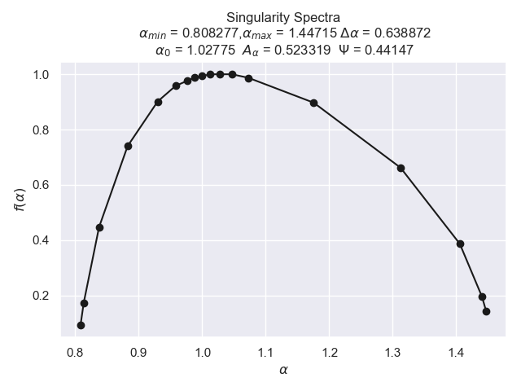

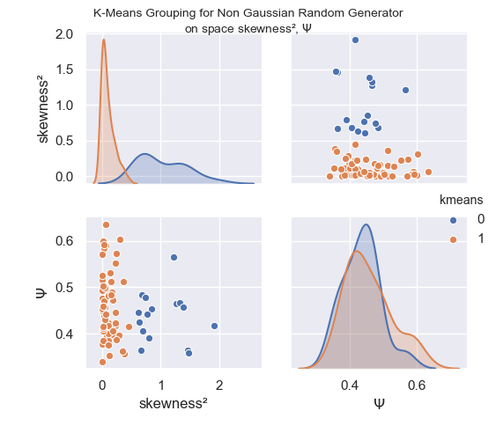

### Colored Noise Generator

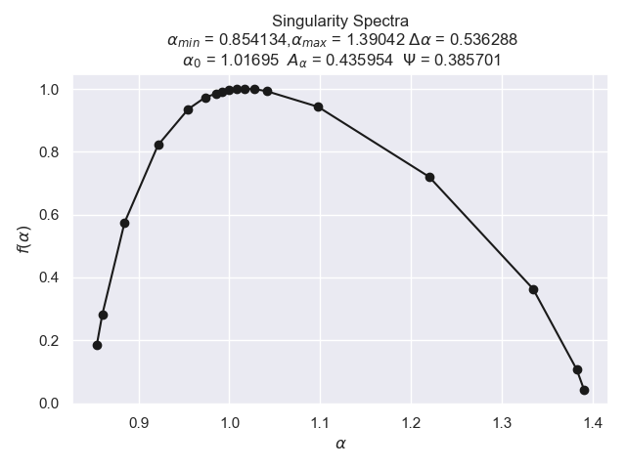

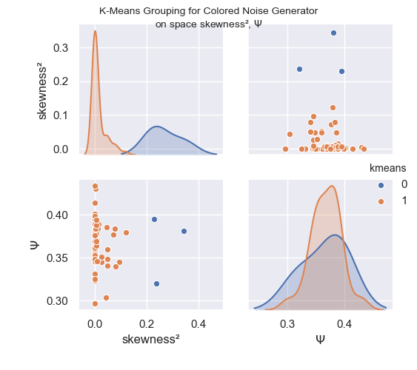

### P-Model

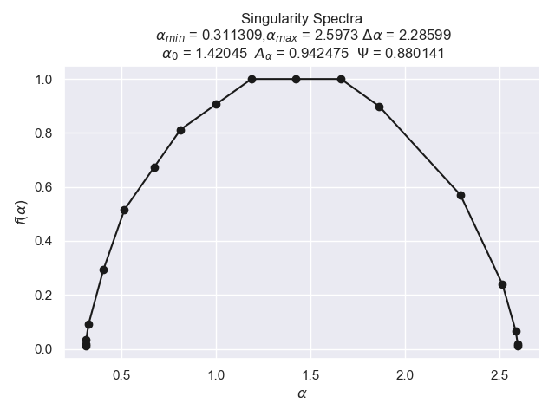

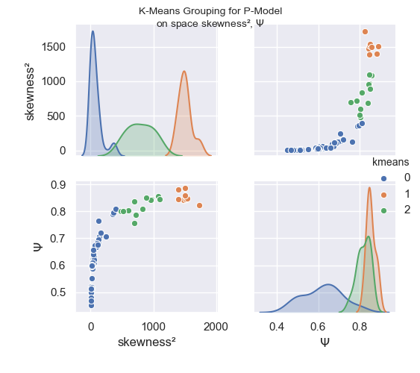

### Logistic Map

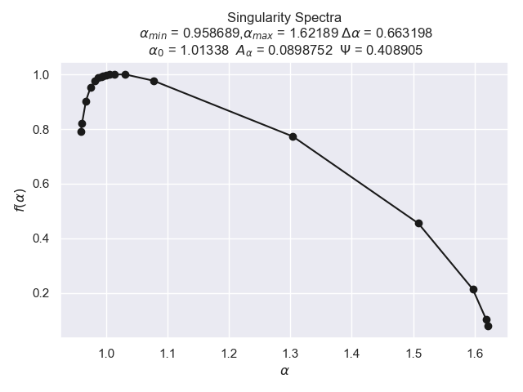

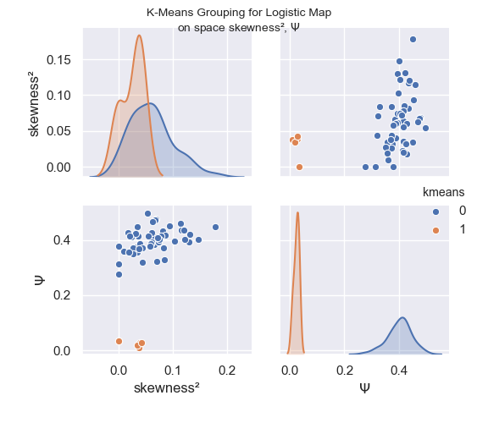

### Henon Map

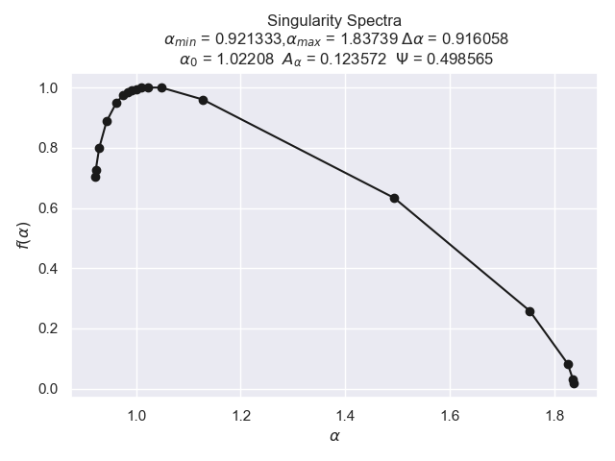

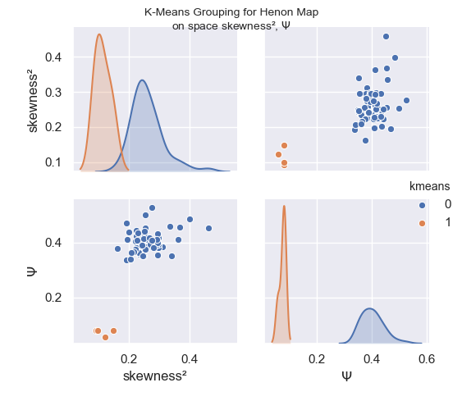

### For all generators:

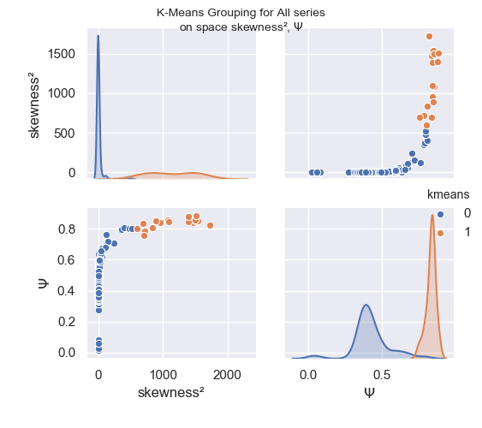

#### Comparing singularity Spectra

Here we show a comparative example of the singularity spectrum for time series generated from different methods, in particular, we see the much wider spectrum of the series generated with P-Model, which is also quite symmetrical, while for the other models, the spectrum is left-truncated, which indicates that the spectrum is insensitive to larger local fluctuations.

The spectrum of the P-Model being the widest, also indicates a higher degree of multifractality and data complexity.

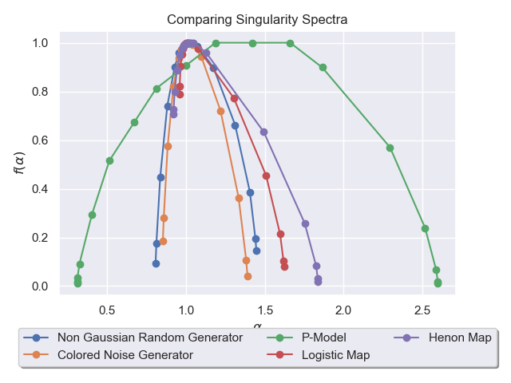

### Exercise 7.3

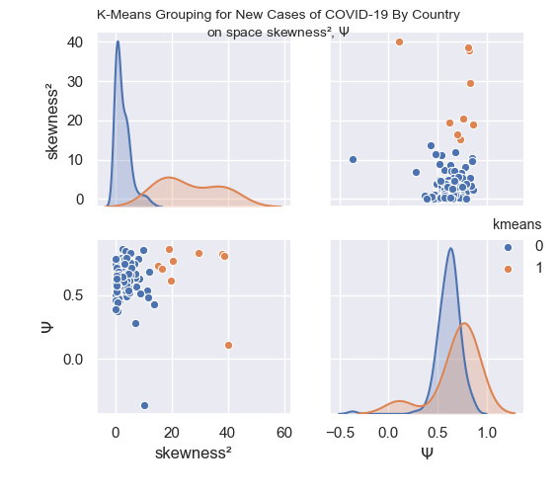

Now, we print the results for each country along with the grouping proposed:

skewness² $\Psi$ Country kmeans group  
0 4.929983 0.737329 Central African Republic 0 0  
0 40.198014 0.110913 Faeroe Islands 1 1  
0 10.334728 0.851464 Maldives 0 0  
0 1.450362 0.687482 Brazil 0 0  
0 2.492821 0.539468 Chile 0 0  
0 0.057677 0.549989 Moldova 0 0  
0 0.202633 0.710258 Singapore 0 0  
0 18.925393 0.865696 Sao Tome and Principe 1 1  
0 3.879811 0.567976 Myanmar 0 0  
0 1.702694 0.647212 Greece 0 0  
0 7.307871 0.568489 Madagascar 0 0  
0 2.128978 0.577360 South Africa 0 0  
0 0.333079 0.508259 Slovenia 0 0  
0 0.057654 0.578791 Russia 0 0  
0 0.101384 0.549911 Italy 0 0  
0 8.648913 0.626472 Ethiopia 0 0  
0 4.121991 0.659845 Malta 0 0  
0 0.039245 0.457992 United Kingdom 0 0  
0 1.316442 0.724524 Andorra 0 0  
0 4.721597 0.575959 Haiti 0 0  
0 0.981396 0.626315 India 0 0  
0 2.175084 0.730597 Tunisia 0 0  
0 7.140901 0.637240 Nepal 0 0  
0 1.321560 0.580162 France 0 0  
0 1.980367 0.794184 South Korea 0 0  
0 1.830543 0.537495 Czech Republic 0 0  
0 11.290277 0.537318 Venezuela 0 0  
0 2.092928 0.680727 Oman 0 0  
0 0.892830 0.506856 Denmark 0 0  
0 0.957196 0.580388 Bulgaria 0 0  
0 6.909623 0.280093 Gibraltar 0 0  
0 8.233686 0.785995 Equatorial Guinea 0 0  
0 1.601927 0.636455 Burkina Faso 0 0  
0 1.070573 0.704257 Colombia 0 0  
0 1.467173 0.454918 Liberia 0 0  
0 1.482140 0.733633 Iceland 0 0  
0 0.422834 0.561843 Qatar 0 0  
0 0.580288 0.698615 Somalia 0 0  
0 4.510562 0.721361 Chad 0 0  
0 5.814925 0.697598 Swaziland 0 0  
0 13.622762 0.428247 Zambia 0 0  
0 1.956095 0.683703 Luxembourg 0 0  
0 1.325827 0.637944 Uruguay 0 0  
0 1.281123 0.628203 Norway 0 0  
0 3.901946 0.622955 Lebanon 0 0  
0 5.410535 0.758939 Cape Verde 0 0  
0 1.149950 0.745657 Bangladesh 0 0  
0 3.654967 0.757263 Sudan 0 0  
0 2.521892 0.613528 Hungary 0 0  
0 3.886317 0.491071 Cameroon 0 0  
0 15.116490 0.728573 South Sudan 1 1  
0 0.019167 0.671172 Panama 0 0  
0 2.765333 0.644367 Rwanda 0 0  
0 0.729030 0.526050 Croatia 0 0  
0 2.468764 0.859518 Iran 0 0  
0 0.189069 0.541051 Poland 0 0  
0 9.706140 0.851750 China 0 0  
0 4.647446 0.575178 Togo 0 0  
0 1.908388 0.676374 Honduras 0 0  
0 0.002317 0.711344 Lithuania 0 0  
0 3.491879 0.540031 Afghanistan 0 0  
0 3.421781 0.845937 New Zealand 0 0  
0 0.208241 0.470028 Malaysia 0 0  
0 29.636860 0.831022 Tanzania 1 1  
0 1.350167 0.589923 San Marino 0 0  
0 5.630992 0.681193 Jersey 0 0  
0 1.167060 0.701570 Kuwait 0 0  
0 3.300508 0.784136 Guinea-Bissau 0 0  
0 0.655120 0.628969 Belgium 0 0  
0 5.294765 0.834002 Australia 0 0  
0 3.604264 0.653150 Gabon 0 0  
0 4.110247 0.624206 Estonia 0 0  
0 0.289422 0.591646 Cuba 0 0  
0 4.116856 0.648965 Kosovo 0 0  
0 20.397149 0.766615 Benin 1 1  
0 0.611815 0.664263 Mali 0 0  
0 0.866226 0.599805 Portugal 0 0  
0 0.284641 0.532925 Dominican Republic 0 0  
0 0.774652 0.635916 Switzerland 0 0  
0 1.923195 0.633786 Cyprus 0 0  
0 0.510143 0.524642 Bosnia and Herzegovina 0 0  
0 0.510387 0.737690 Nigeria 0 0  
0 1.042293 0.471629 Puerto Rico 0 0  
0 3.594521 0.642471 Montenegro 0 0  
0 6.675924 0.742956 Ghana 0 0  
0 0.163612 0.525761 Turkey 0 0  
0 4.367243 0.601864 Sierra Leone 0 0  
0 0.000673 0.736029 United Arab Emirates 0 0  
0 3.223909 0.651846 Iraq 0 0  
0 1.833140 0.569111 Uzbekistan 0 0  
0 7.133255 0.666112 Isle of Man 0 0  
0 4.355623 0.667162 Guam 0 0  
0 0.819227 0.371691 Senegal 0 0  
0 5.566954 0.718571 Japan 0 0  
0 0.820070 0.578630 Guinea 0 0  
0 1.171850 0.488924 Azerbaijan 0 0  
0 1.465938 0.643236 Kyrgyzstan 0 0  
0 2.947096 0.649821 Taiwan 0 0  
0 0.002463 0.603193 Ukraine 0 0  
0 2.815139 0.685874 Austria 0 0  
0 0.288073 0.677033 Philippines 0 0  
0 0.297407 0.493998 Albania 0 0  
0 0.652697 0.610987 Costa Rica 0 0  
0 19.580510 0.616237 Uganda 1 1  
0 37.822406 0.821231 Palestine 1 1  
0 5.485914 0.660766 Mozambique 0 0  
0 0.072929 0.625765 Algeria 0 0  
0 0.656829 0.519232 Kazakhstan 0 0  
0 3.834250 0.573255 Yemen 0 0  
0 0.037626 0.508038 Sweden 0 0  
0 0.682732 0.663019 Spain 0 0  
0 2.047977 0.653828 Israel 0 0  
0 1.190708 0.472973 World 0 0  
0 4.150665 0.607538 Niger 0 0  
0 5.361762 0.754220 Mauritius 0 0  
0 4.117660 0.679231 Slovakia 0 0  
0 2.450815 0.567459 Argentina 0 0  
0 4.451831 0.664844 Vietnam 0 0  
0 8.972552 0.516844 Syria 0 0  
0 4.961820 0.610407 Kenya 0 0  
0 3.659337 0.651311 Georgia 0 0  
0 0.444545 0.667313 Peru 0 0  
0 4.945854 0.518206 Brunei 0 0  
0 0.384417 0.717378 Tajikistan 0 0  
0 0.647029 0.651793 Germany 0 0  
0 11.542053 0.482232 Sri Lanka 0 0  
0 2.543750 0.627909 Macedonia 0 0  
0 38.705327 0.811326 Ecuador 1 1  
0 0.764101 0.643495 Bahrain 0 0  
0 3.981207 0.616590 Latvia 0 0  
0 11.946241 0.680367 Bermuda 0 0  
0 0.156166 0.456439 Netherlands 0 0  
0 5.556237 0.714938 Djibouti 0 0  
0 10.118350 -0.366717 Mauritania 0 0  
0 3.754995 0.617199 Jamaica 0 0  
0 0.963184 0.663438 El Salvador 0 0  
0 0.005239 0.787823 Belarus 0 0  
0 0.998097 0.585111 Finland 0 0  
0 3.802329 0.575879 Congo 0 0  
0 1.015743 0.683595 Egypt 0 0  
0 1.490397 0.569145 Ireland 0 0  
0 0.616365 0.440806 Indonesia 0 0  
0 3.022034 0.604260 Guernsey 0 0  
0 3.983541 0.789059 Thailand 0 0  
0 4.542406 0.666447 Democratic Republic of Congo 0 0  
0 0.152061 0.626064 Canada 0 0  
0 16.490405 0.703756 Paraguay 1 1  
0 0.590303 0.528747 Serbia 0 0  
0 0.164908 0.584153 Morocco 0 0  
0 1.013826 0.661524 Jordan 0 0  
0 3.173414 0.747125 Bolivia 0 0  
0 2.546705 0.647621 Armenia 0 0  
0 4.520122 0.534822 Guatemala 0 0  
0 0.413701 0.526043 Cote d'Ivoire 0 0  
0 0.802064 0.572024 Mexico 0 0  
0 0.344648 0.574355 United States 0 0  
0 0.233458 0.650414 Saudi Arabia 0 0  
0 0.467714 0.627345 Pakistan 0 0  
0 0.000745 0.392374 Romania 0 0

## Exercise 8

Here we compare the Continuous Wavelet Spectrum for time series generated with each signal generator used so far.  
 Both Morley and DOG wavelet charts are used.

### Non Gaussian Random Generator

#### Morley:

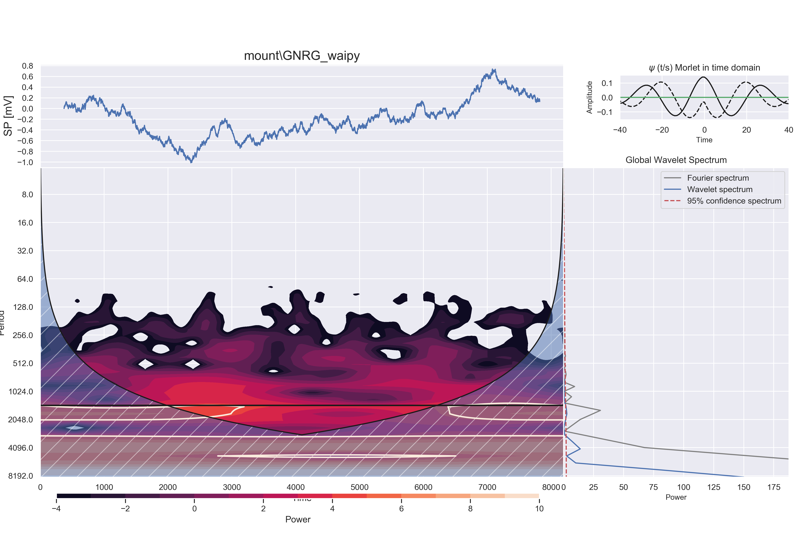

#### DOG:

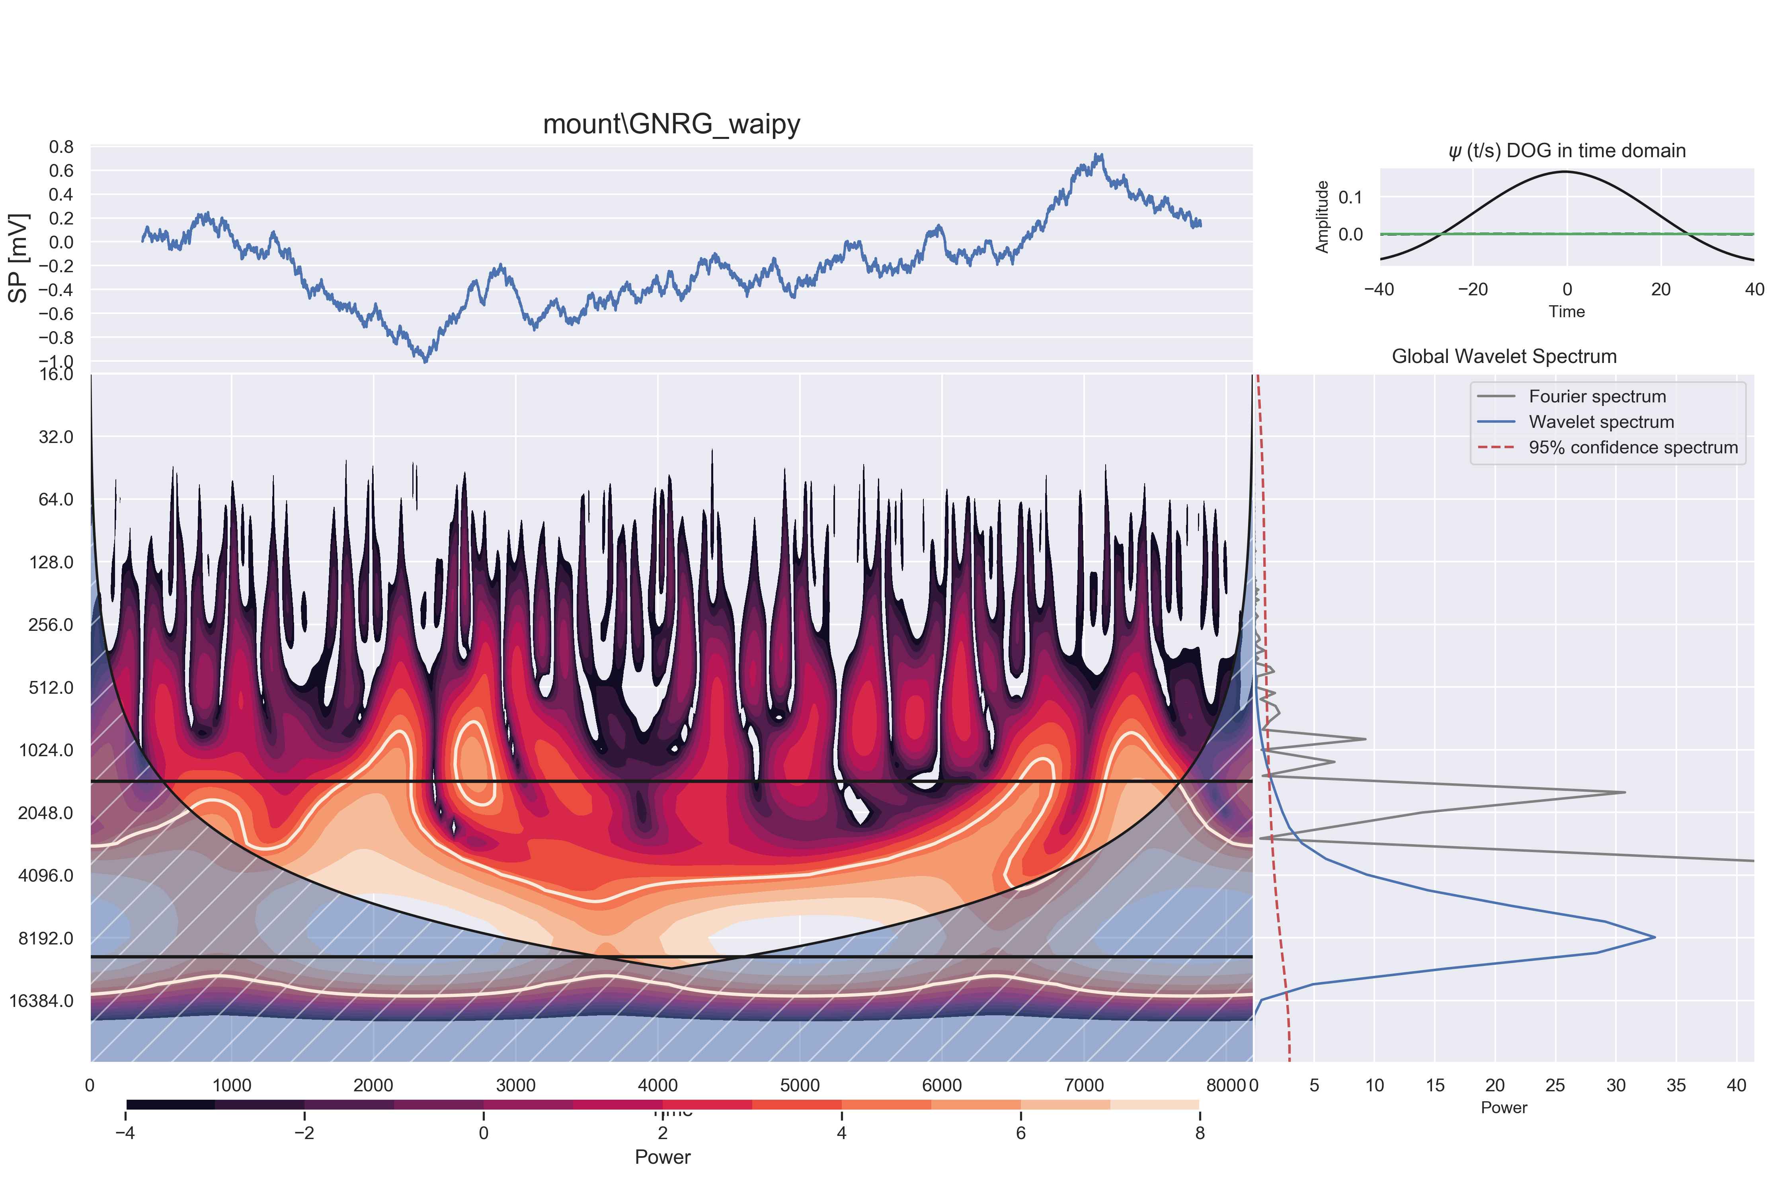

### Colored Noise Generator

#### Morley:

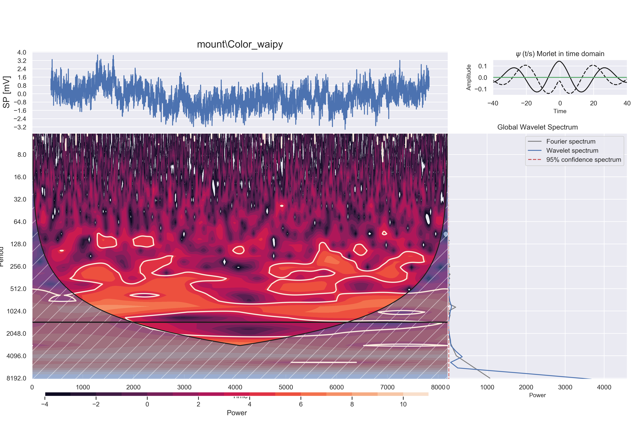

#### DOG:

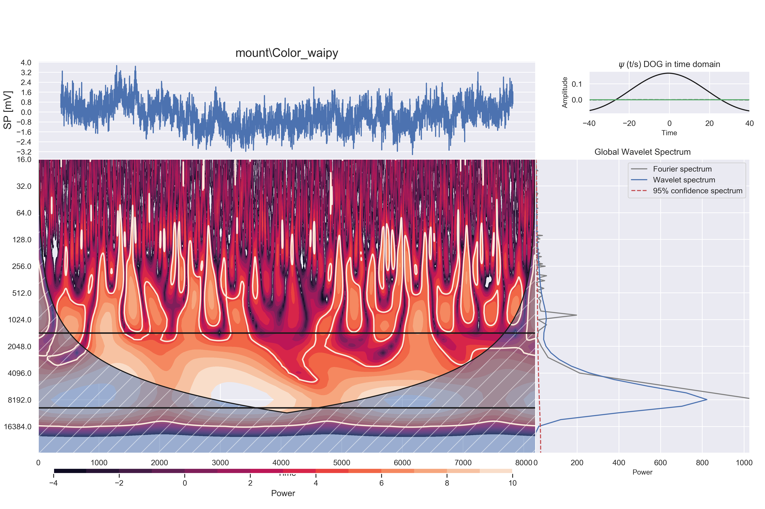

### P-Model

#### Morley:

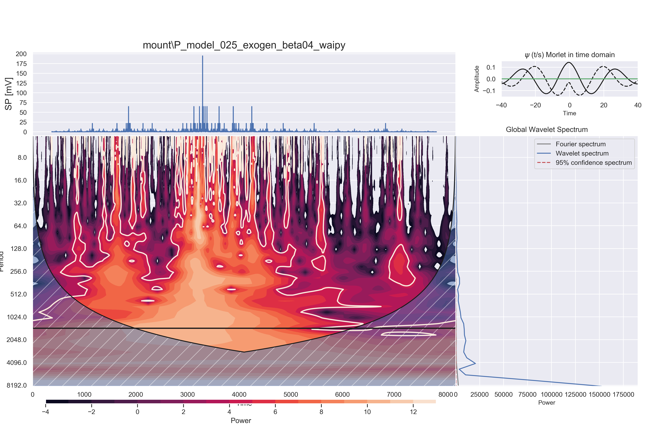

#### DOG:

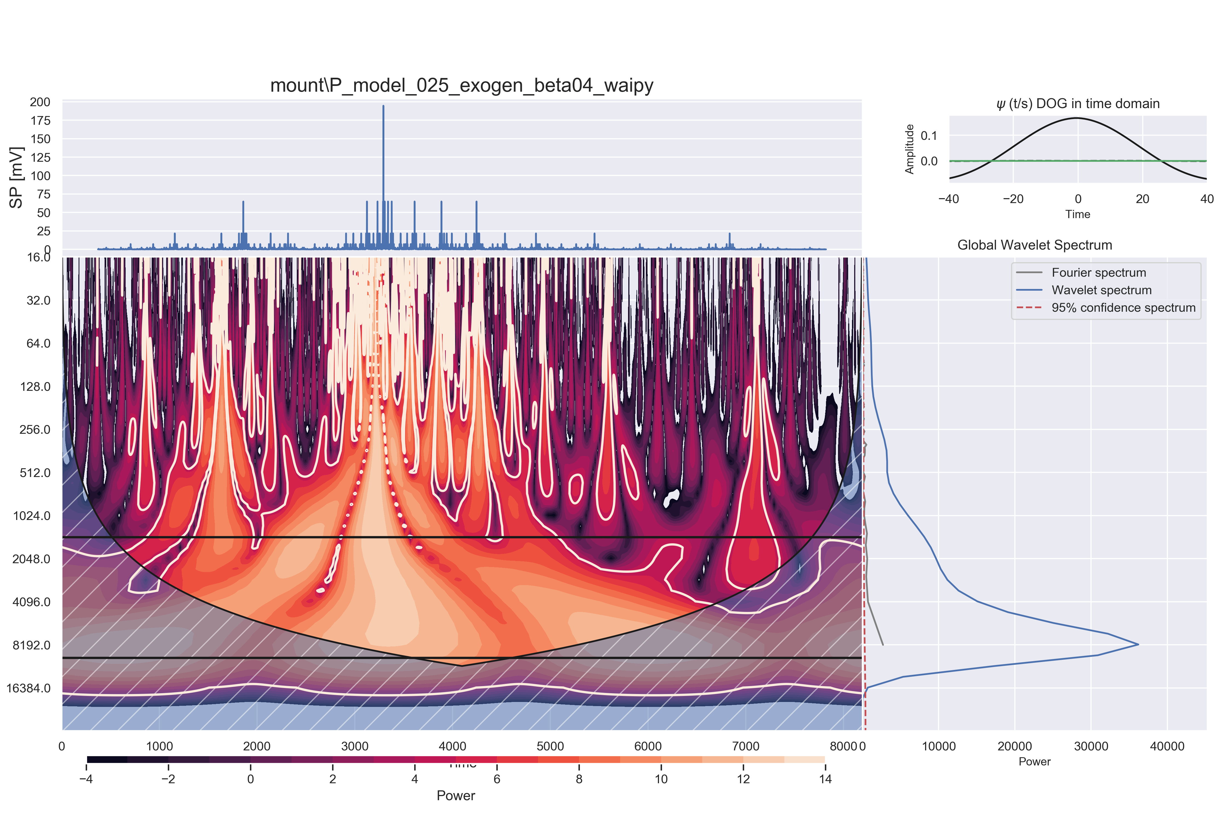

### Logistic Map

#### Morley:

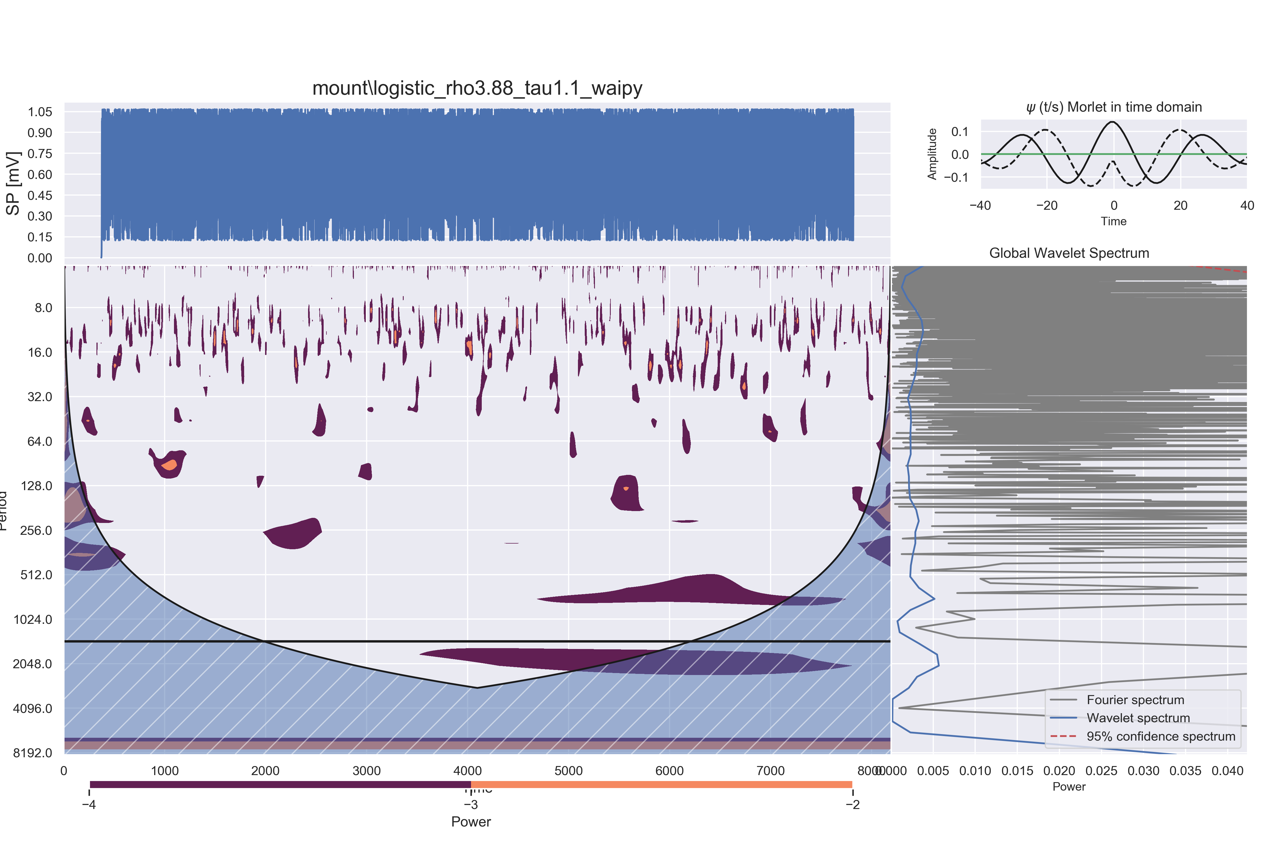

#### DOG:

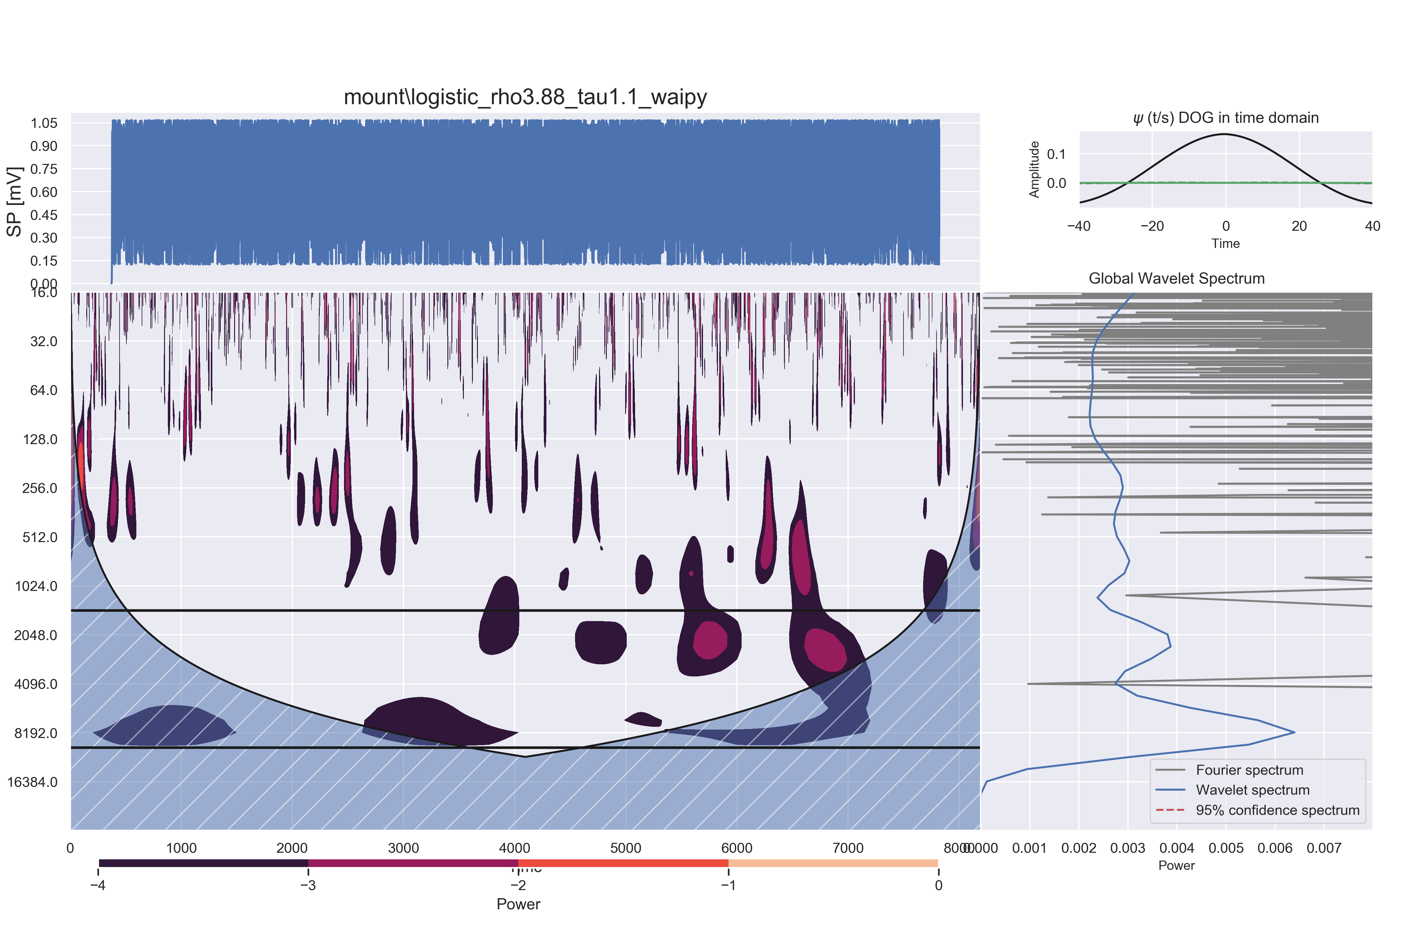

### Henon Map

#### Morley could not be computed for Henon Map

The received error message was:   
Filled contours require at least 2 levels.

#### DOG could not be computed for Henon Map

The received error message was:   
Filled contours require at least 2 levels.

## Exercise 9

### Exercise 9.1

Due to the low diversity of numbers contained in a p-model generated time series, the aggregation used by the soc.py algorithm often produces few points or empty bins, resulting in poor charts for this generator.

## For endogenous series:

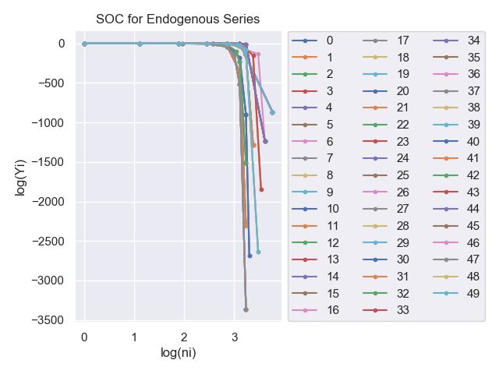

## For endogenous series:

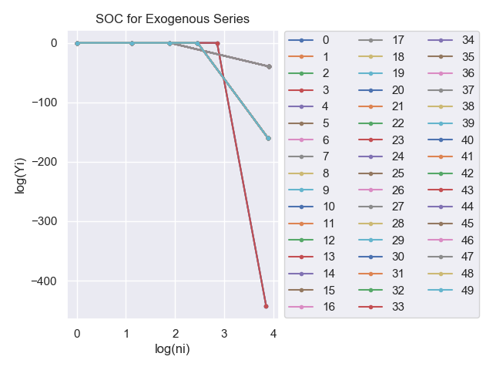

### Exercise 9.2

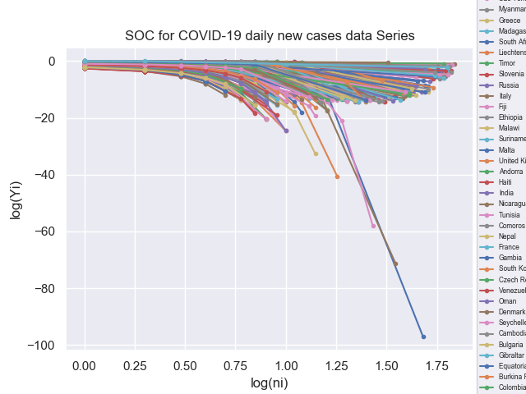

A few countries were excluded from this analysis, because they crashed the soc.py script, these are:Hong Kong, International

Now, we repeat the process for a few select countries

